**INT213-PYTHON**



**PYTHON PROJECT**

## **Topic:**

**Final Project Report**

**ROCK PAPER SCISSOR GAME-**

**Submitted To:** Mr. Sagar Pande Sir

**D.O.S**: November 3, 2020

**Section:** K19JC

## **Group Members:**

1. **ISHA BHAGAT-** **11903855**
2. **SIMRAN MUJRAL- 11904577**
3. **SRIJAN PANDA-** **12000985**

**ACKNOWLEDGEMENT**

We would like to express our heartily gratitude to our University as well as our INT213 Faculty Mr. Sagar Pande Sir, who gave us this opportunity to work on the project “ROCK PAPER SCISSOR GAME**”.** This project had helped us a lot in understanding the working of GUIs and other applications

### TABLE OF CONTENT-

### 1. Introduction

1. Introduction to the System
2. Problem Definition
3. Objective

### 2. System Analysis

1. Purpose
2. Project Scope
3. System Description

**3. System Design**

1. Introduction
2. Conceptual Design

### 4.OUTPUT SCREEN

[**5. Conclusion**](#chap 9)

1. **INTRODUCTION-**
2. Introduction to the System
3. Problem Definition

c. Objective

**INTRODUCTION TO THE SYSTEM-**

The ROCK,PAPER,SCISSOR game had been designed in such a way that the user can play with the computer and according to the choices, the points of the user and the computer interface are calculated. It provides a user-friendly experience. The user will have a graphical user interface experience which will make the game more interactive and interesting.

The colors used in GUI offers a bright contrast with the background.

**PROBLEM DEFINITION-**

This project deals with the implementation of ROCK,PAPER, SCISSOR game in which user can enter his/her choice and

Can play with the computer.

**OBJECTIVE-**

The objective of this poject is to develop such a user friendly game experience to compell the user to play with the computer. The user can enter his/ choice during the game and play with the computer.

**2. System Analysis**

1. Purpose
2. Project Scope
3. System Description

**PURPOSE-**

The purpose of our designed game is to provide the user an interactive and a friendly experience to make the game more interesting. There are several windows with different widgets used where the user can play with a more interactive and responsive system. These widgets are designed to develop the keen interest of the user in the game.

**PROJECT SCOPE-**

The project is implemented in such a way to provide the user a friendly experience with the computer and to make the game more interesting and interactive. It can be played anywhere with only one user at a time.

**SYSTEM DESCRIPTION**

This project is made using several widgets in order to make the game more interesting. It consists of labels, buttons, windows etc to enhance the visuality. The role of each widget is described as follows-

1. BUTTON-  A **button** is a widget which is designed for the user to interact with, i.e. if the **button** is pressed by mouse click some action might be started. The button click makes the game more interesting.
2. LABELS-A label is a graphical control element which displays text on a form. It is usually a static control, having no interactivity. A label is generally used to identify a nearby text box or other widget.
3. **SYSTEM DESIGN**

**INTRODUCTION-**

The library is imported snd a new window namely”Rock paper scissor game” is created. The buttons used are-play, start, exit and rules. These buttons have different functionalities. Play button is used to provide an option to the user to play and continue the game. The rule button is used to open the rule window where the user can get familiar with the rules of the game before playing. Start button is used to start the game according to the user’s choice and exit button is used to close the game at any stage depending upon the user.

**FUNCTIONALITY(CONCEPTUAL DESIGN)-**

When the user clicks on “play” button, the main window is destroyed and play function is executed. A new window is created which contains start and exit buttons. When the user clicks on “start” button,he/she gets the option to choose between –“rock”,”paper”,”scissor” and the game begins. The computer choice is stored in throw and both the choices are compared. Based on the given conditions, individual scores are calculated. The game continues and the user gets the option to choose according to his/her desire. When the user clicks on exit function, the “comp-win” window will get destroyed and the user will be allowed to exit the game. On clicking on “rules” button, the user will be able to see the rules in the form of “labels”

**OUTPUT SCREEN AND CODE**

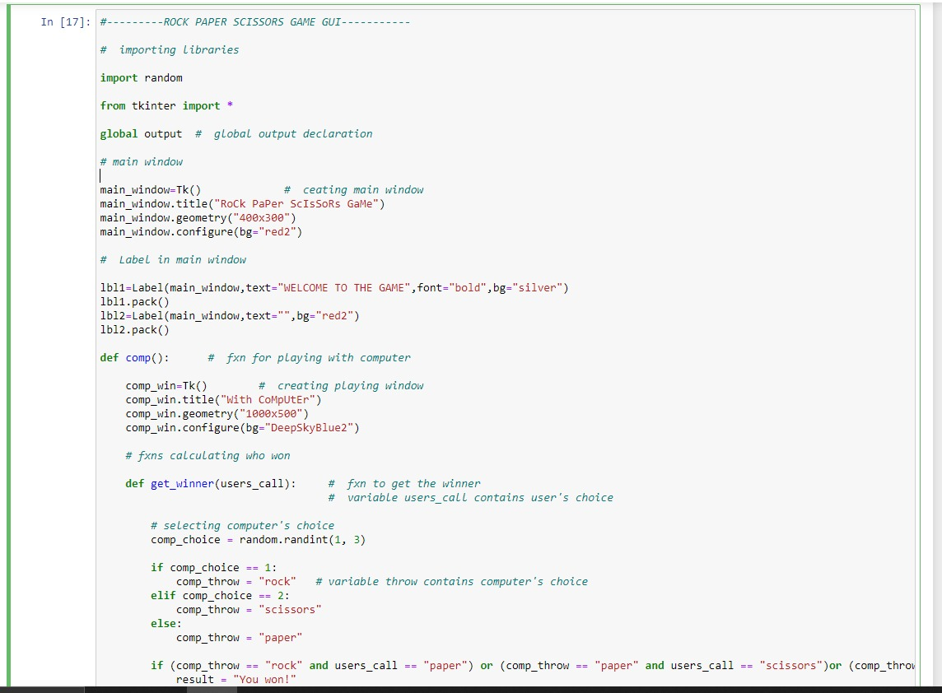

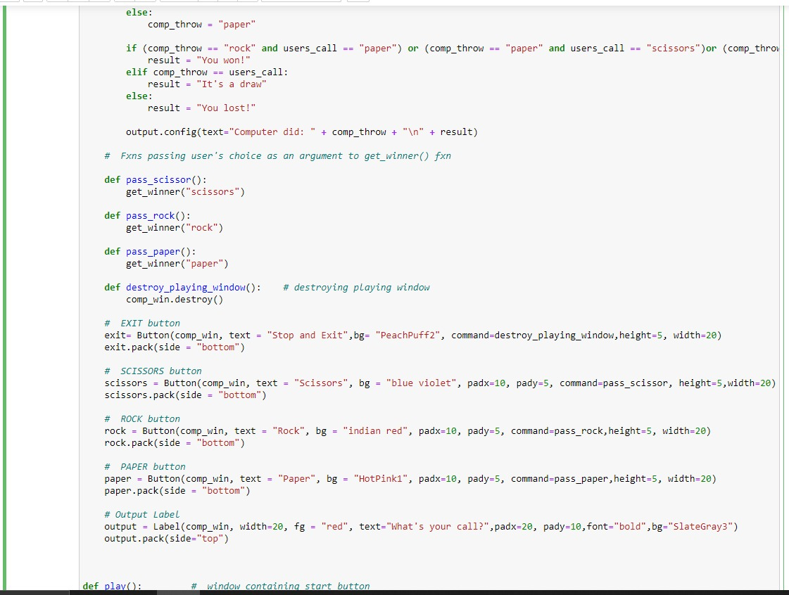

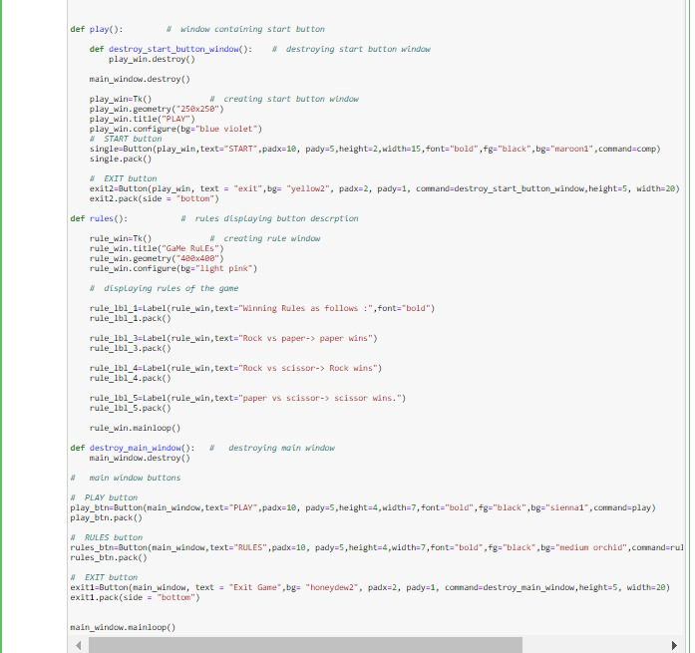

**#---------ROCK PAPER SCISSORS GAME GUI-----------**

**# importing libraries**

**import random**

**from tkinter import \***

**global output # global output declaration**

**# main window**

**main_window=Tk() # ceating main window**

**main_window.title("RoCk PaPer ScIsSoRs GaMe")**

**main_window.geometry("400x300")**

**main_window.configure(bg="red2")**

**# Label in main window**

**lbl1=Label(main_window,text="WELCOME TO THE GAME",font="bold",bg="silver")**

**lbl1.pack()**

**lbl2=Label(main_window,text="",bg="red2")**

**lbl2.pack()**

**def comp(): # fxn for playing with computer**

**comp_win=Tk() # creating playing window**

**comp_win.title("With CoMpUtEr")**

**comp_win.geometry("1000x500")**

**comp_win.configure(bg="DeepSkyBlue2")**

**# fxns calculating who won**

**def get_winner(users_call): # fxn to get the winner**

**# variable users_call contains user's choice**

**# selecting computer's choice**

**comp_choice = random.randint(1, 3)**

**if comp_choice == 1:**

**comp_throw = "rock" # variable throw contains computer's choice**

**elif comp_choice == 2:**

**comp_throw = "scissors"**

**else:**

**comp_throw = "paper"**

**if (comp_throw == "rock" and users_call == "paper") or (comp_throw == "paper" and users_call == "scissors")or (comp_throw == "scissors" and users_call == "rock"):**

**result = "You won!"**

**elif comp_throw == users_call:**

**result = "It's a draw"**

**else:**

**result = "You lost!"**

**output.config(text="Computer did: " + comp_throw + "\n" + result)**

**# Fxns passing user's choice as an argument to get_winner() fxn**

**def pass_scissor():**

**get_winner("scissors")**

**def pass_rock():**

**get_winner("rock")**

**def pass_paper():**

**get_winner("paper")**

**def destroy_playing_window(): # destroying playing window**

**comp_win.destroy()**

**# EXIT button**

**exit= Button(comp_win, text = "Stop and Exit",bg= "PeachPuff2", command=destroy_playing_window,height=5, width=20)**

**exit.pack(side = "bottom")**

**# SCISSORS button**

**scissors = Button(comp_win, text = "Scissors", bg = "blue violet", padx=10, pady=5, command=pass_scissor, height=5,width=20)**

**scissors.pack(side = "bottom")**

**# ROCK button**

**rock = Button(comp_win, text = "Rock", bg = "indian red", padx=10, pady=5, command=pass_rock,height=5, width=20)**

**rock.pack(side = "bottom")**

**# PAPER button**

**paper = Button(comp_win, text = "Paper", bg = "HotPink1", padx=10, pady=5, command=pass_paper,height=5, width=20)**

**paper.pack(side = "bottom")**

**# Output Label**

**output = Label(comp_win, width=20, fg = "red", text="What's your call?",padx=20, pady=10,font="bold",bg="SlateGray3")**

**output.pack(side="top")**

**def play(): # window containing start button**

**def destroy_start_button_window(): # destroying start button window**

**play_win.destroy()**

**main_window.destroy()**

**play_win=Tk() # creating start button window**

**play_win.geometry("250x250")**

**play_win.title("PLAY")**

**play_win.configure(bg="blue violet")**

**# START button**

**single=Button(play_win,text="START",padx=10, pady=5,height=2,width=15,font="bold",fg="black",bg="maroon1",command=comp)**

**single.pack()**

**# EXIT button**

**exit2=Button(play_win, text = "exit",bg= "yellow2", padx=2, pady=1, command=destroy_start_button_window,height=5, width=20)**

**exit2.pack(side = "bottom")**

**def rules(): # rules displaying button descrption**

**rule_win=Tk() # creating rule window**

**rule_win.title("GaMe RuLEs")**

**rule_win.geometry("400x400")**

**rule_win.configure(bg="light pink")**

**# displaying rules of the game**

**rule_lbl_1=Label(rule_win,text="Winning Rules as follows :",font="bold")**

**rule_lbl_1.pack()**

**rule_lbl_3=Label(rule_win,text="Rock vs paper-> paper wins")**

**rule_lbl_3.pack()**

**rule_lbl_4=Label(rule_win,text="Rock vs scissor-> Rock wins")**

**rule_lbl_4.pack()**

**rule_lbl_5=Label(rule_win,text="paper vs scissor-> scissor wins.")**

**rule_lbl_5.pack()**

**rule_win.mainloop()**

**def destroy_main_window(): # destroying main window**

**main_window.destroy()**

**# main window buttons**

**# PLAY button**

**play_btn=Button(main_window,text="PLAY",padx=10, pady=5,height=4,width=7,font="bold",fg="black",bg="sienna1",command=play)**

**play_btn.pack()**

**# RULES button**

**rules_btn=Button(main_window,text="RULES",padx=10, pady=5,height=4,width=7,font="bold",fg="black",bg="medium orchid",command=rules)**

**rules_btn.pack()**

**# EXIT button**

**exit1=Button(main_window, text = "Exit Game",bg= "honeydew2", padx=2, pady=1, command=destroy_main_window,height=5, width=20)**

**exit1.pack(side = "bottom")**

**main_window.mainloop()**

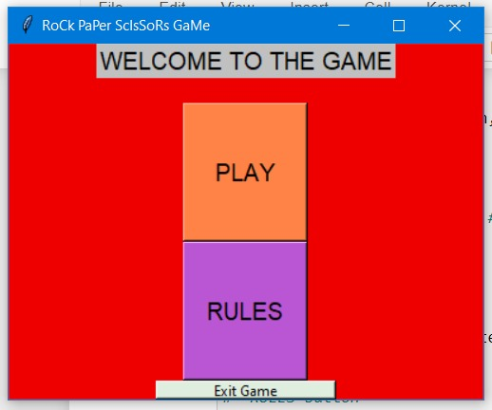

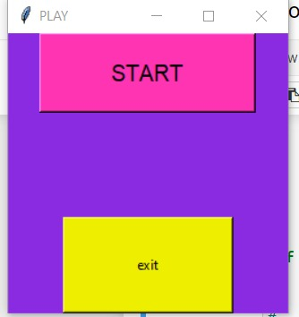

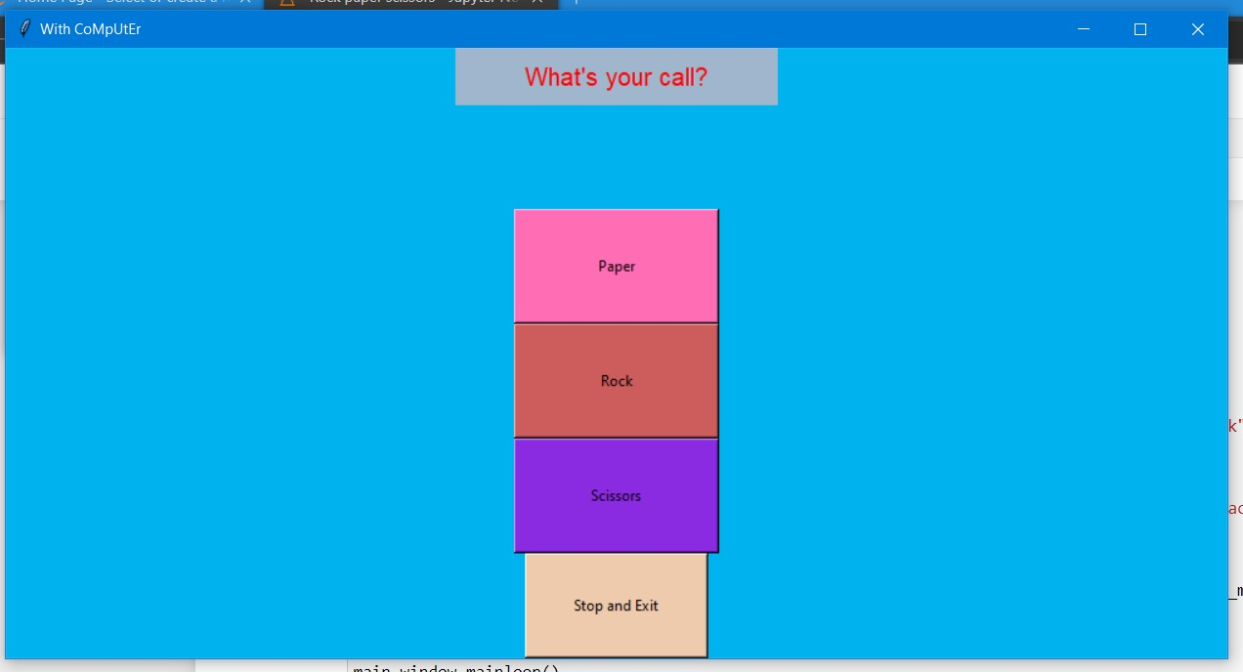

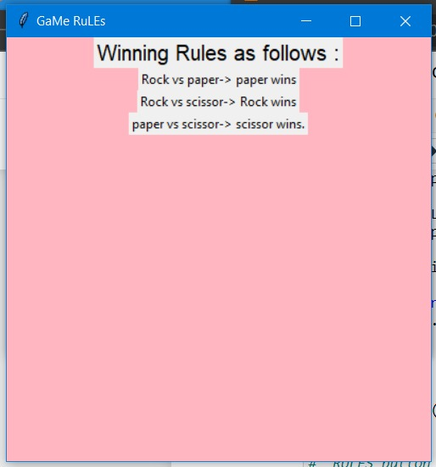

**CONCLUSION-**

The game “rock,paper,scissor” as designed using the gui windows and widgets to offer a user friendly experience to the user and to make the game more interactive and interesting.

THANKYOU